1Day Cultural Activities:

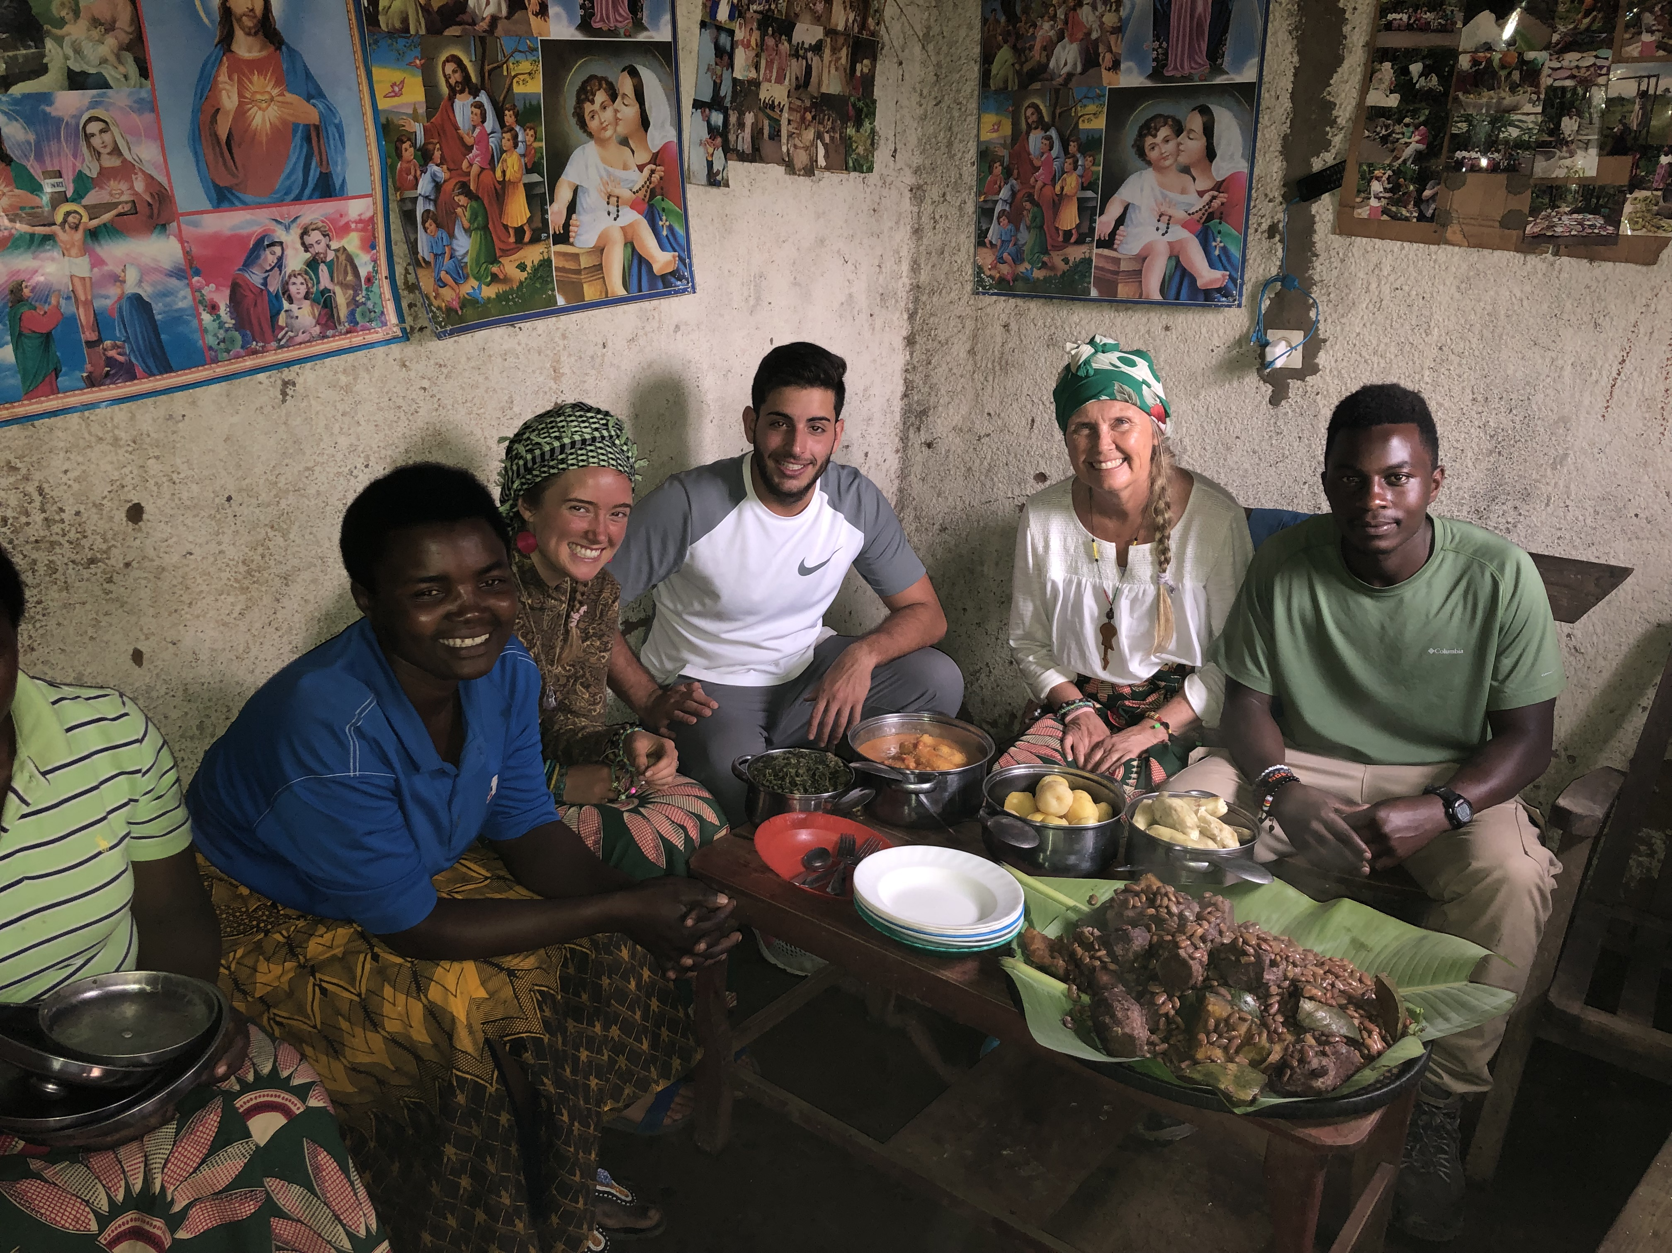

After your heavy breakfast, you will be picked up by our English speaking guide at the hotel in musanze for the whole day tour, He will take you to one of the local community family, participate with themto learn the methods of farming, Become part of a village family’s daily chores by beginning the morning in the gardens cutting grass for the animals and getting out in the fields for a seasonal agricultural activity.
You will love the setting with the community guide for a chat after a pretty much physical activity in the garden
Thereafter, harvest some food from the farms, visit the local market, join them learn the art of cooking with the local in homestay setting and be introduced to various cooking’s mainly preferred by the locals.

After your lunch later I the afternoon hours participate in banana beer making, have an opportunity to experience Rwandan traditional living and what makes it authentic. Get a practical experience on grinding sorghum on the traditional grinding stone to make food and beer, you can join the production and grinding of sorghum that works as the fermenting catalyst,
Learn how to weave baskets as a long history and culture of making beautiful hand craft items. Agaseke basket is a decorating gift item given the daughters during marriage ceremonies. It’s a precious feminine gift that has connotation of beauty and love. The tour ends with a Traditional Rwandan cultural dancing,then back to the hotel for dinner and overnight.

