ONE DAY GORILLA TRECK

DAY1: PICK UP IN KIGALI AND TRAVEL TO MUSANZE FOR GORILLA TRACKING AND BACK
You will be picked up by our English speaking guide at 0430hrs In the morning and transfer for a 2 hour’s drive to Musanze Ruhengeri the second largest town in Rwanda, with its spectacular view of five volcanic mountains –The virungas. Then continue to kinigi RDB Headquarters to meet your guides for the day.
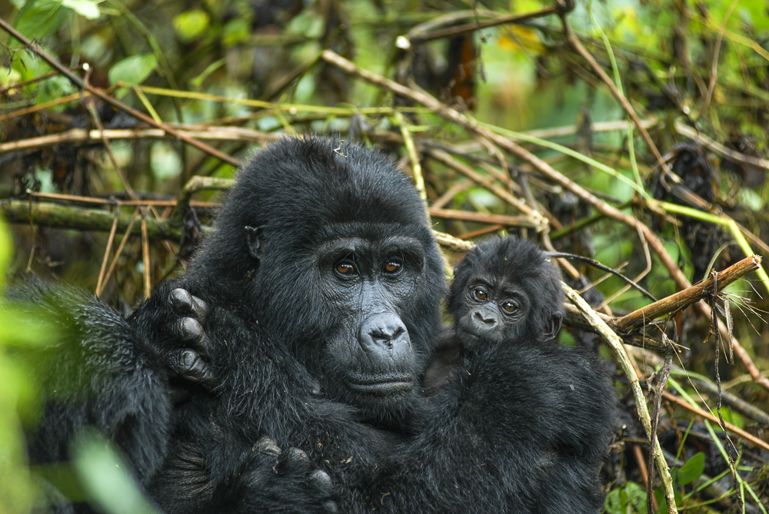

After completing our park formalities, we embark in life for once in a lifetime experience for mountain gorilla tracking. Once you spot them, you are allowed to spend an hour watching your closest long lost cousins. This perhaps one of the most breath taking wildlife experience on earth, you get so close to these awesome giant primates. You stare at each others blankly not knowing who to break the long silence first.Tracking the gorillas through the light mountain forest on the slopes of the virunga is a magical experience! These massive giants are extremely rare with less than 700 living today. You will get within meters of the family, and be privileged to spend an hour amongst them. The tracking maybe fairly strenuous rare, up to six hours or longer at a relatively high altitude .For your enjoyment, we encourage your to make sure that you are perfectly fit and healthy. (we’ve had people as old as 70yrs old do gorilla tracking so this should be not be a problem .All you need to ask your driver guide is to request a shorter group for you if you cannot trek far). Its important to bring good hiking boots ,long trousers, gloves for protecting against stinging nettles ,some snack and sweets( for you not the gorillas) as well as sufficient water as the rain forest gets hot and humid during the day. You will spend one hour with the gorillas, but it’s an hour you will never forget. Return to musanze ruhengeri to freshen up and have lunch then depart for a 2 hour’s drive back t Kigali.
End of service. 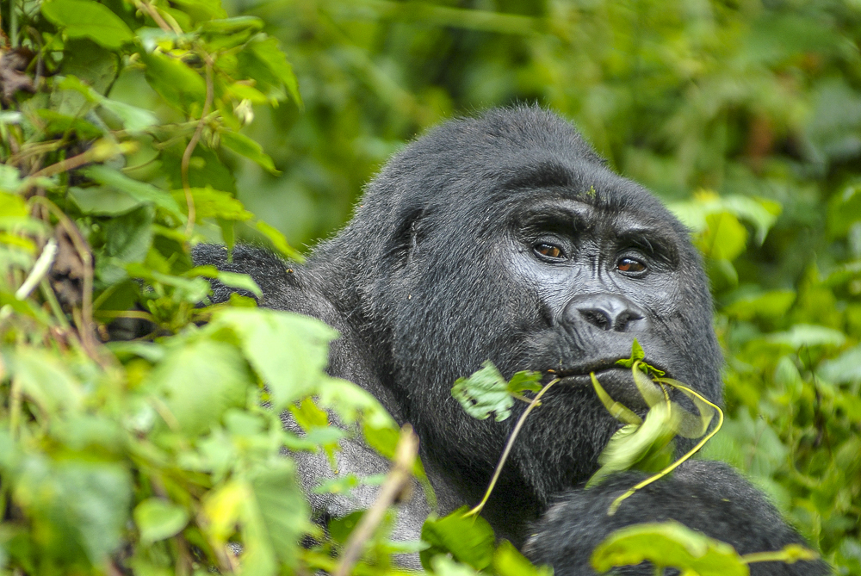

Driving Distance: 2 hours (both ways )
Activities : Gorilla Tracking
Overnight :0
Meal plan : lunch

Cost includes;
Transport in a 4WD safari vehicle exclusive to you
English speaking Guide
All guide fees
One gorilla tracking permit per person

Cost excludes ;
international flights and visa
Travel insurances
Driver guide or local escort tips
Drinking and dining rooms tips, porters, personal travel and luggage
Telephone bill, laundry and any item of a personal nature
Activities not mentioned in a program.

